**Assignment2**

**241574109**

**Wajih Ur Rehman**

**Note: I used windows subsystem for linux to do this assignment.**

**1. Generate a Private and Public Key Pair**

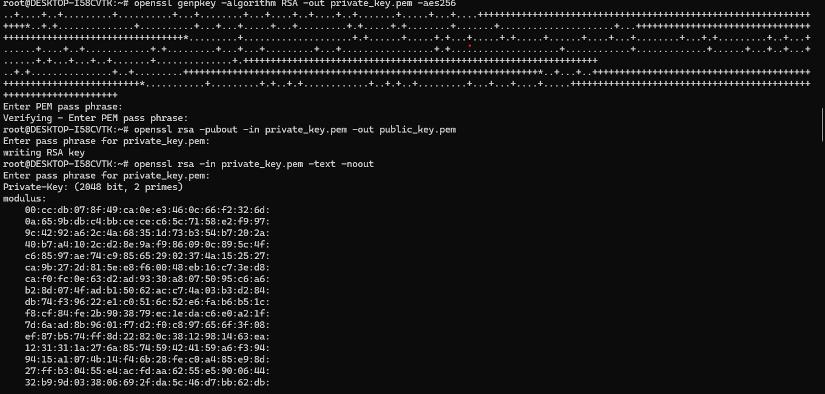

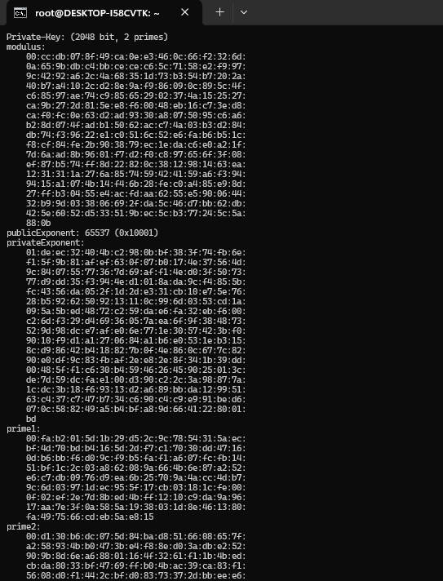

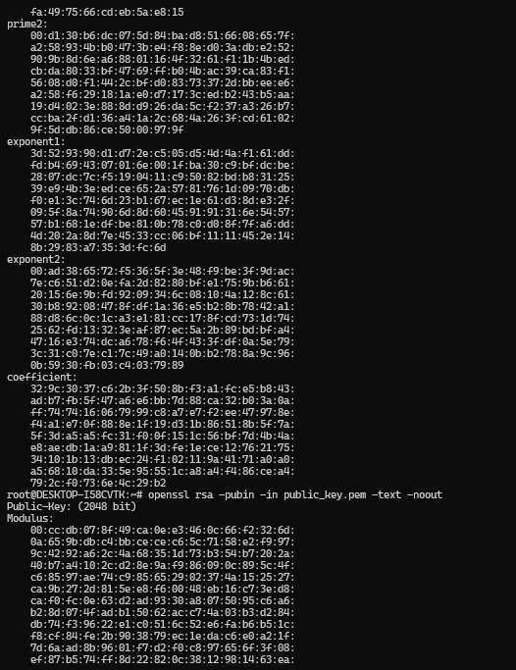

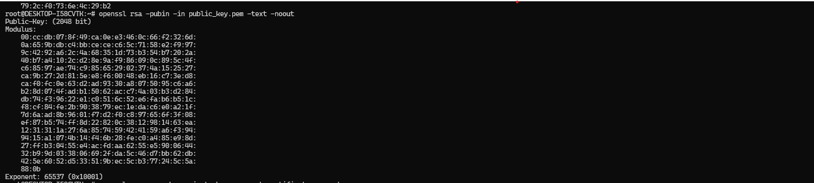

**2.Generate a Certificate Signing Request (CSR)**

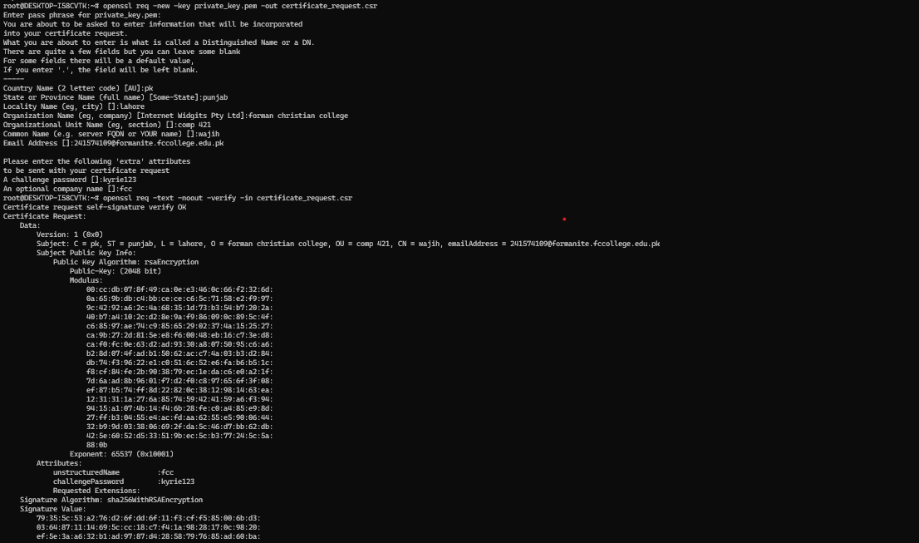

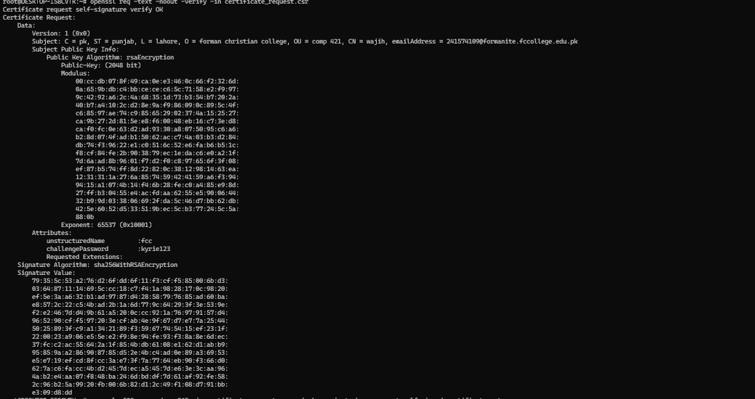

**3. Create a Self-Signed Certificate**

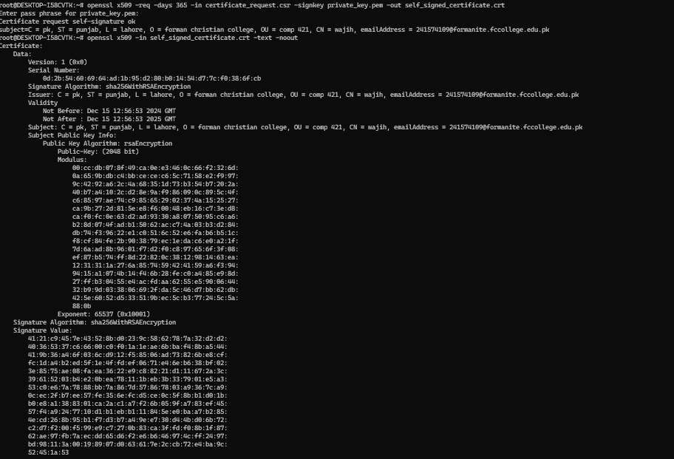

**4. Act as a Certification Authority (CA)**

